Yaxiaer Atajiang

Eric Neiman

AI: Project 1

Part A: by Yaxiaer Atajiang

Create, understand, explore a data set

# Written in R

# Creating artificial data here.

mHeight = rnorm(n = 2000, mean = 69, sd = 6)

fHeight = rnorm(n = 2000, mean = 63, sd = 6)

mWeight = rnorm(n = 2000, mean = 196, sd = 6)

fWeight = rnorm(n = 2000, mean = 177, sd = 6)

# Create Data frame

artif_data = data.frame("Height" = mHeight, "Height2" = fHeight, "Weight" = mWeight, "Weight2" = fWeight)

# Write data as csv

write.csv(artif_data, file = "D:/\User\/Programming Projects/R/r-mf-feature-normal-dist/data.csv")

# Height only unsorted

plot((mHeight), main = "Height Only", xlab = "Population", ylab = "Height (Inches)", pch = 20, col = "blue")

points((fHeight), pch = 20, col = "red")

abline(h = 68, col = "green", lwd = 4, lty = 2)

legend(0, 88, legend = c("Male", "Female", "Separation Line Y=68"), col = c("blue", "red", "green"), lty = 1)

# Height and weight unsorted

plot((mWeight), (mHeight), main = "Height and Weight", xlab = "Weight (lb)", ylab = "Height (Inches)", pch = 20, col = "blue")

points((fWeight), (fHeight), pch = 20, col = "red")

abline(8251/17, -38/17, col = "green", lwd = 4, lty = 2)

legend(195, 89, legend = c("Male", "Female", "Separation Line Y=(-38X + 8251)/17"), col = c("blue", "red", "green"), lty = 1)

# Calculations

# Get guess below or above the given inequality

count = 0

index = 1

# For non-sloped line

for (x in mHeight) { # Chamge the variable depending on the gender or use

if(x < 68) { # Chamge the inequality depending on the gender or use

count = count + 1

}

}

# For sloped line

while (index < 2001) {

if (mHeight[index] >= (-38*mWeight[index] + 8251)/17) {

count = count + 1

}

index = index + 1

}

Scenarios

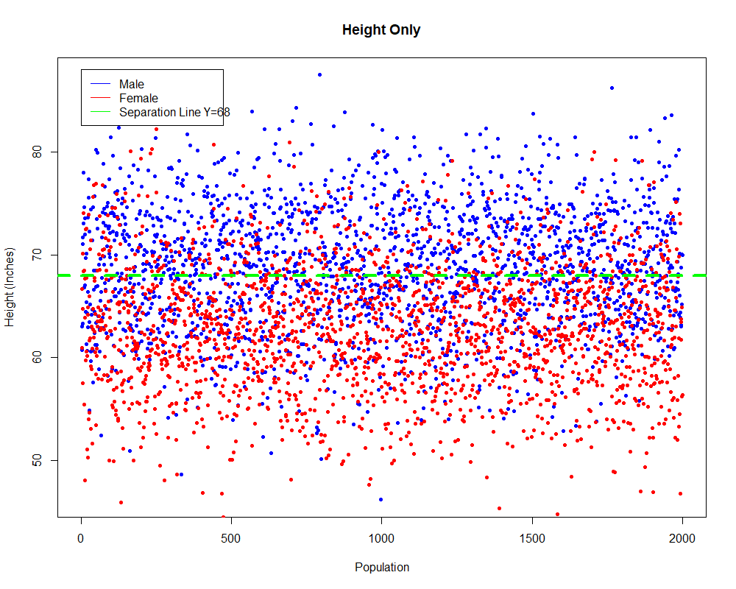Definition of the neuron: Fire if height value is over the threshold (T = 68). If neuron fires, the input is most likely male, else, female. Therefore: (W1)*X – 68 >= 0 where W1 = 1.

Accuracy = 68.3%

Error = 31.7%

True Positive = 55.55%

False Positive = 18.95%

True Negative = 81.05%

False Negative = 44.45%

Definition of the neuron: 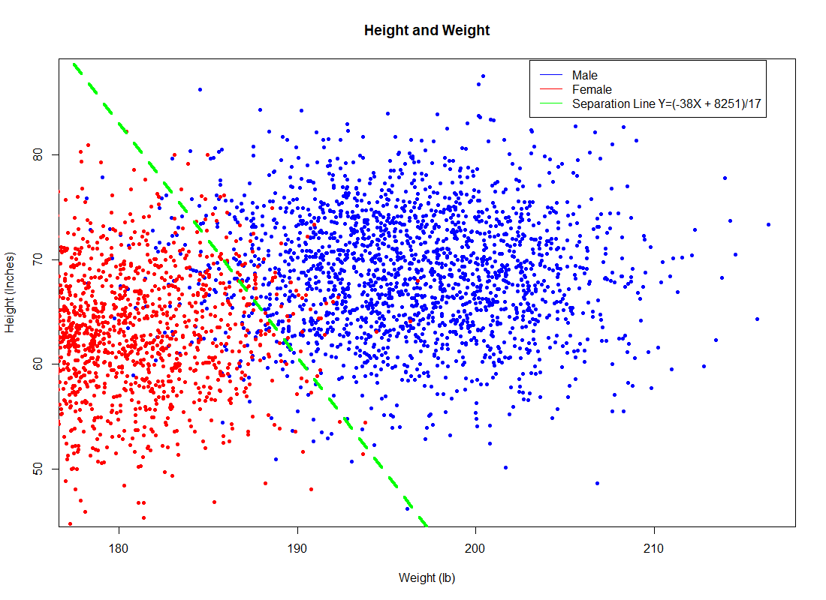Fire if input is most likely male. Therefore: W1*X + W2*Y + bias >=0, where W1 = 38, W2 = 17, and bias = -8251.

Accuracy = 94.85%

Error = 5.15%

True Positive = 93.50%

False Positive = 3.80%

True Negative = 96.02%

False Negative = 6.50%

Part B: by Eric Neiman

|  |  |  |  |  |
| --- | --- | --- | --- | --- |
| Write 1 | Write 0 | Memory | Inequalities | Out |
| 1 | 0 | 0 | 1 + 0 + 0 < 0.5 | 1 |
| 1 | 1 | 0 | 1 - 2 + 0 < 0.5 | 0 |
| 1 | 0 | 1 | 1 + 0 + 1 > 0.5 | 1 |
| 1 | 1 | 1 | 1 - 2 + 1 < 0.5 | 0 |
| 0 | 0 | 0 | 0 + 0 + 0 < 0.5 | 0 |
| 0 | 1 | 0 | 0 - 2 + 0 < 0.5 | 0 |
| 0 | 0 | 1 | 0 + 0 + 1 > 0.5 | 1 |
| 0 | 1 | 1 | 0 - 2 + 1 < 0.5 | 0 |

1. 1. When the memory has a stored zero: Range = { -2 , 1 }
   2. When the memory has a stored one: Range = { -2 , 2 }
2. We cannot consider any case when Write 0 is true because the weight of Write 0 is -2 and the combined weights of Write 1 and the Memory are 2. Therefore, the neuron can never fire if Write 0 is true because it cannot reach the activation threshold of 0.5.